SAFETY EXPERTS
Shop No. 4614-15 Gali Shahtara ,Ajmeri Gate Delhi -6
Ph.011-23215050, 30114467,43517483
E-Mail -Rahulsakhuja@yahoo.com

Fire suits
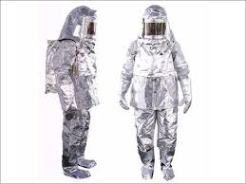
Fire approach suits
Aluminized fire approach suit having outer layer of aluminized fabric and inner lining of woolen fabric complete with overall in one piece in different sizes I e. 1600 mm, 1560 mm or smaller. Hood with FRP Helmet and visor made of two sheets each of mica, gold vaporized polycarbonate and acrylic marking the visor reflective type and heat/impact resistant and shatter proof and brass jali 2’’ * 2’’ two pcs on face side duly covered which is good for natural breathing, gloves 3/5 fingers type 380 mm long properly insulated pair of ankle/ leg guards ( optional ) shoes in different size 10 and 9 or smaller. With leather lining properly insulated soles.

Fire Proximity Suit
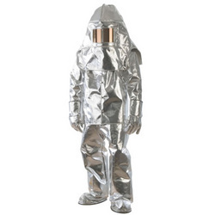
Proximity SUITS
Proximity suits are designed for exterior rescue operations and other fire situations where there are hazards and people operating in excessive temperature within the manufacturer's recommended operating range.
The outer layer of these aluminized ensembles help to reflect more than 90 percent of the radiant heat thereby helping the rescuer prolong their stay near a fire.
Modern Apparels' fire proximity suit is made of 16-ounce imported aluminized glass fiber fabric with dual mirror having 90 percent reflection of heat as an outer layer and with a woolen fabric lining. An additional vapor-barrier layer is also used for higher temperature.
Fyrepel's 700 and 705 Series proximity suits are designed for performing maintenance and repairs in high-heat areas. Fyrepel's multi-layer construction includes a vapor barrier and an outer layer composed of high-temperature aluminized glass. The 700 Series suit comes with a hood with gold reflective face shield, coat, pants, mitts and boots.
Globe's RSX ensembles use a reflective aluminized film for radiant heat resistance that is laminated to a knit PBI blend for the outer shell. Globe Cairns proximity gear is available with a choice of moisture barriers and thermal liners as well as a variety of custom options.
WE RESERVE THE RIGHT TO CHANGE THE SPECIFICATION FOR IMPROVEMENT OF PRODUCT WITHOUT ANY NOTICE

